Task : Create an EFS and connect it to 3 different EC2 instances. Make sure that
all instances have different operating systems. For instance, Ubuntu, Red
Hat Linux and Amazon Linux 2.

Step 1: Create 3 instance having different operating systems (Ubuntu, Red Hat Linux and Amazon Linux 2)
NOTE: Make sure in inbound rule NFA must enable.
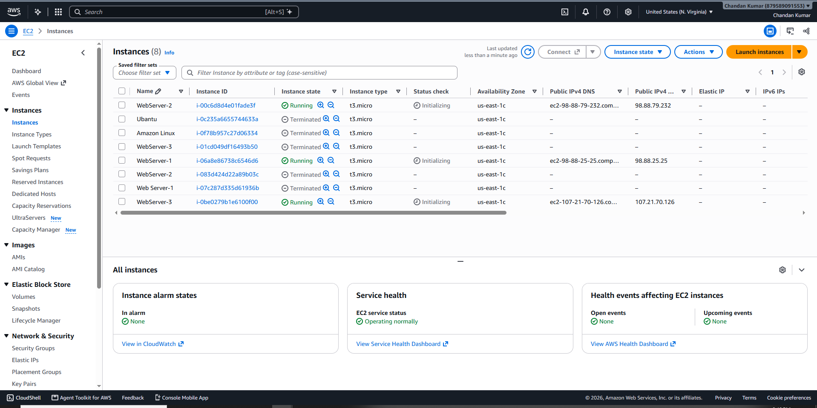
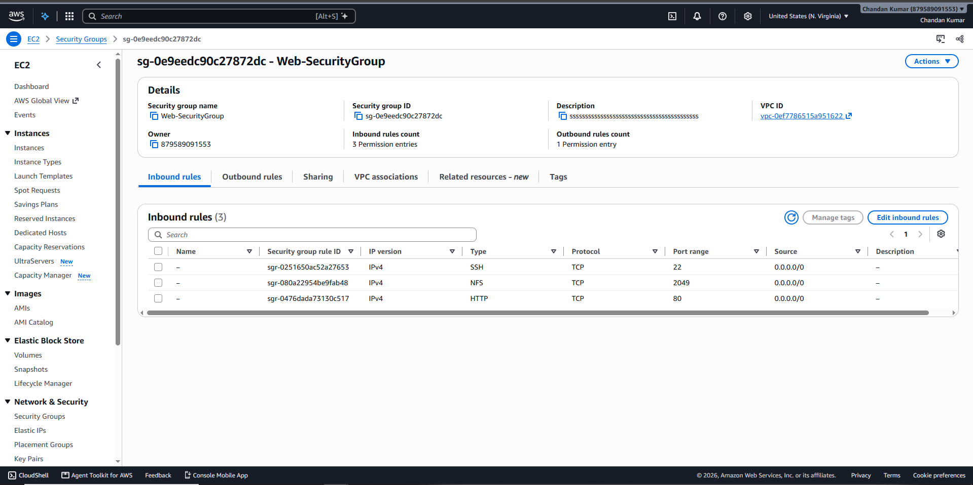
Step 2: Create EFS > Click on search EFS > Click on create file system > Name = ShareDrive > Customize > File system type = Regional > Next > Mount target = us-east-1c > Next > Next > create.
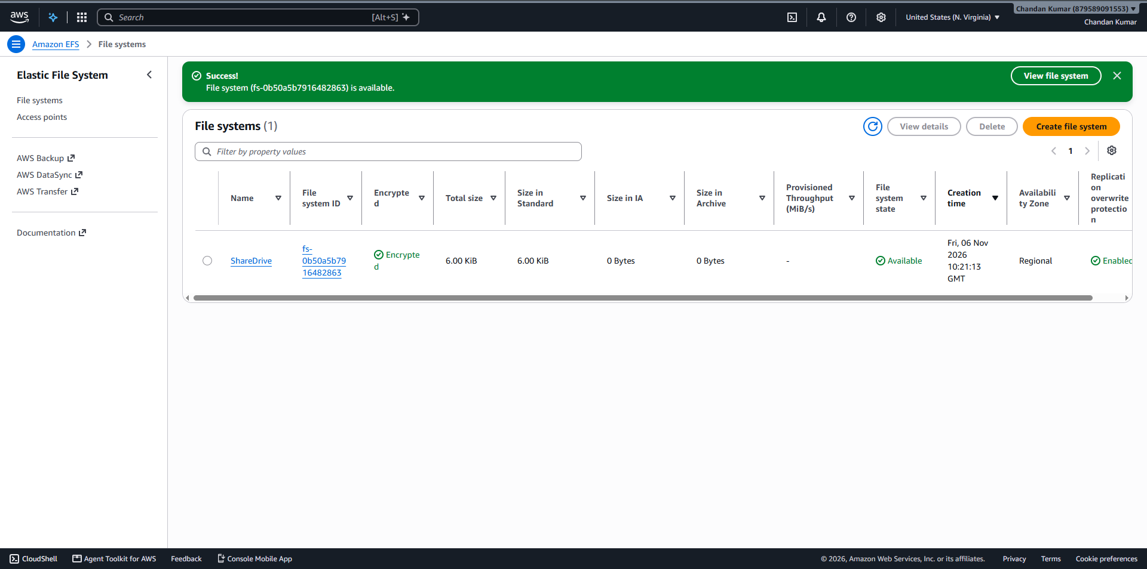
Step 3: Open Ubuntu instance > run these commands > sudo apt update > sudo apt install -y nfs-common (NFS-Agent) > sudo mkdir -p /test1 > sudo mount -t nfs4 -o nfsvers=4.1,rsize=1048576,wsize=1048576,hard,timeo=600,retrans=2,noresvport fs-0b50a5b7916482863.efs.us-east-1.amazonaws.com:/ /test1 > Create one file inside EFS.
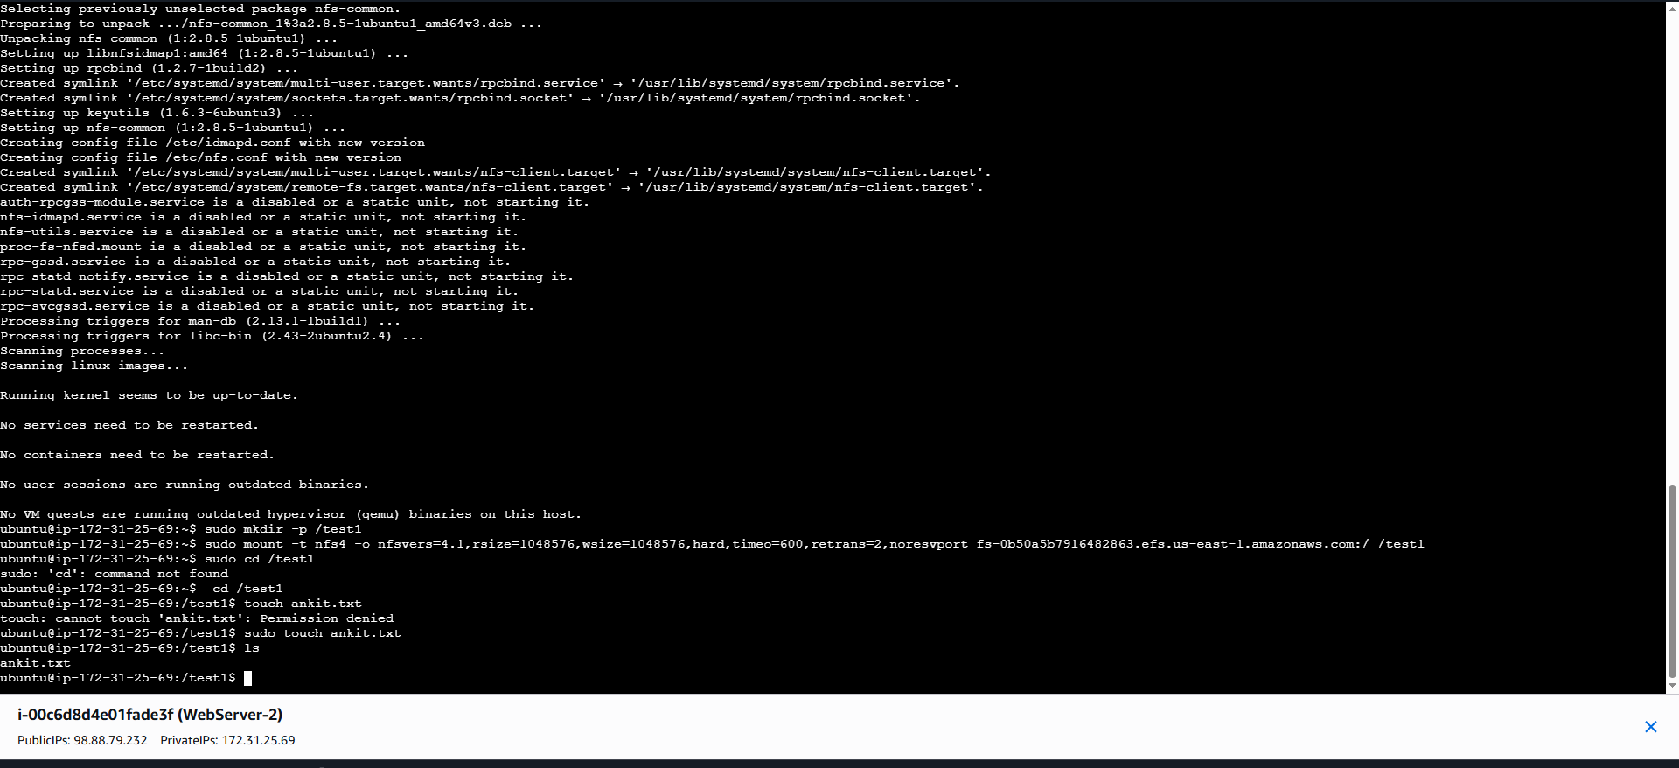
Step 4: Open Amazon linux instance > Run some commands > sudo yum install -y nfs-utils > sudo mkdir -p /test2 > sudo mount -t nfs4 -o nfsvers=4.1,rsize=1048576,wsize=1048576,hard,timeo=600,retrans=2,noresvport fs-0b50a5b7916482863.efs.us-east-1.amazonaws.com:/ /test2
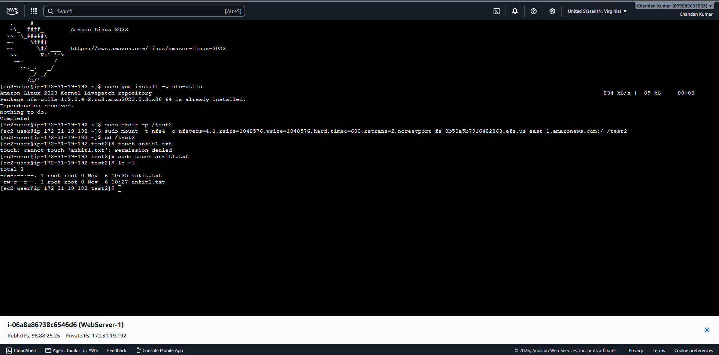
Step 5: Connect Redhat linux > run some commands > sudo dnf install -y nfs-utils > sudo mkdir -p /test3 > sudo mount -t nfs4 -onfsvers=4.1,rsize=1048576,wsize=1048576,hard,timeo=600,retrans=2,noresvport fs-0b50a5b7916482863.efs.us-east-1.amazonaws.com:/ /test3.
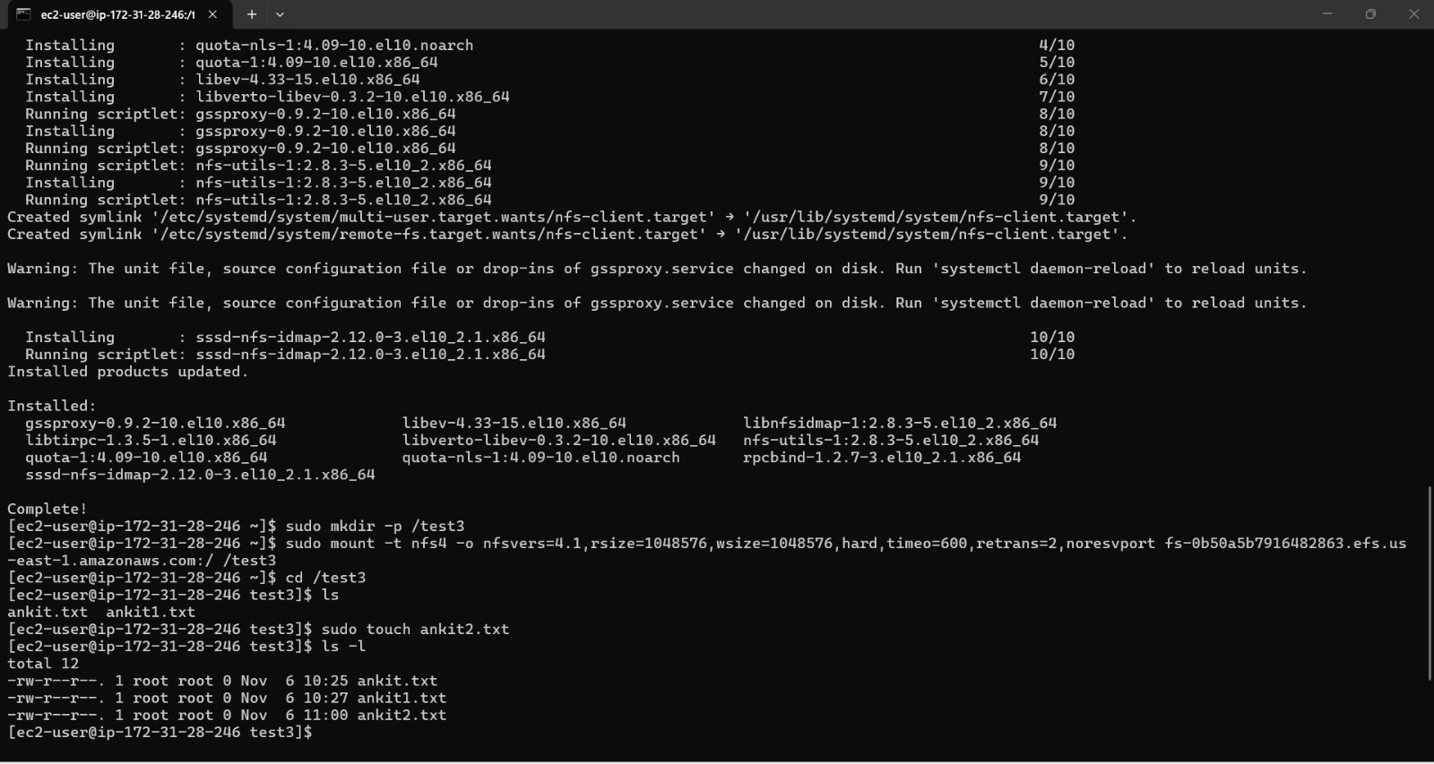
NOTE: As tested by created folders in every EC2 instance same folder was replicated in every different instance .

